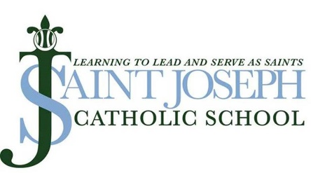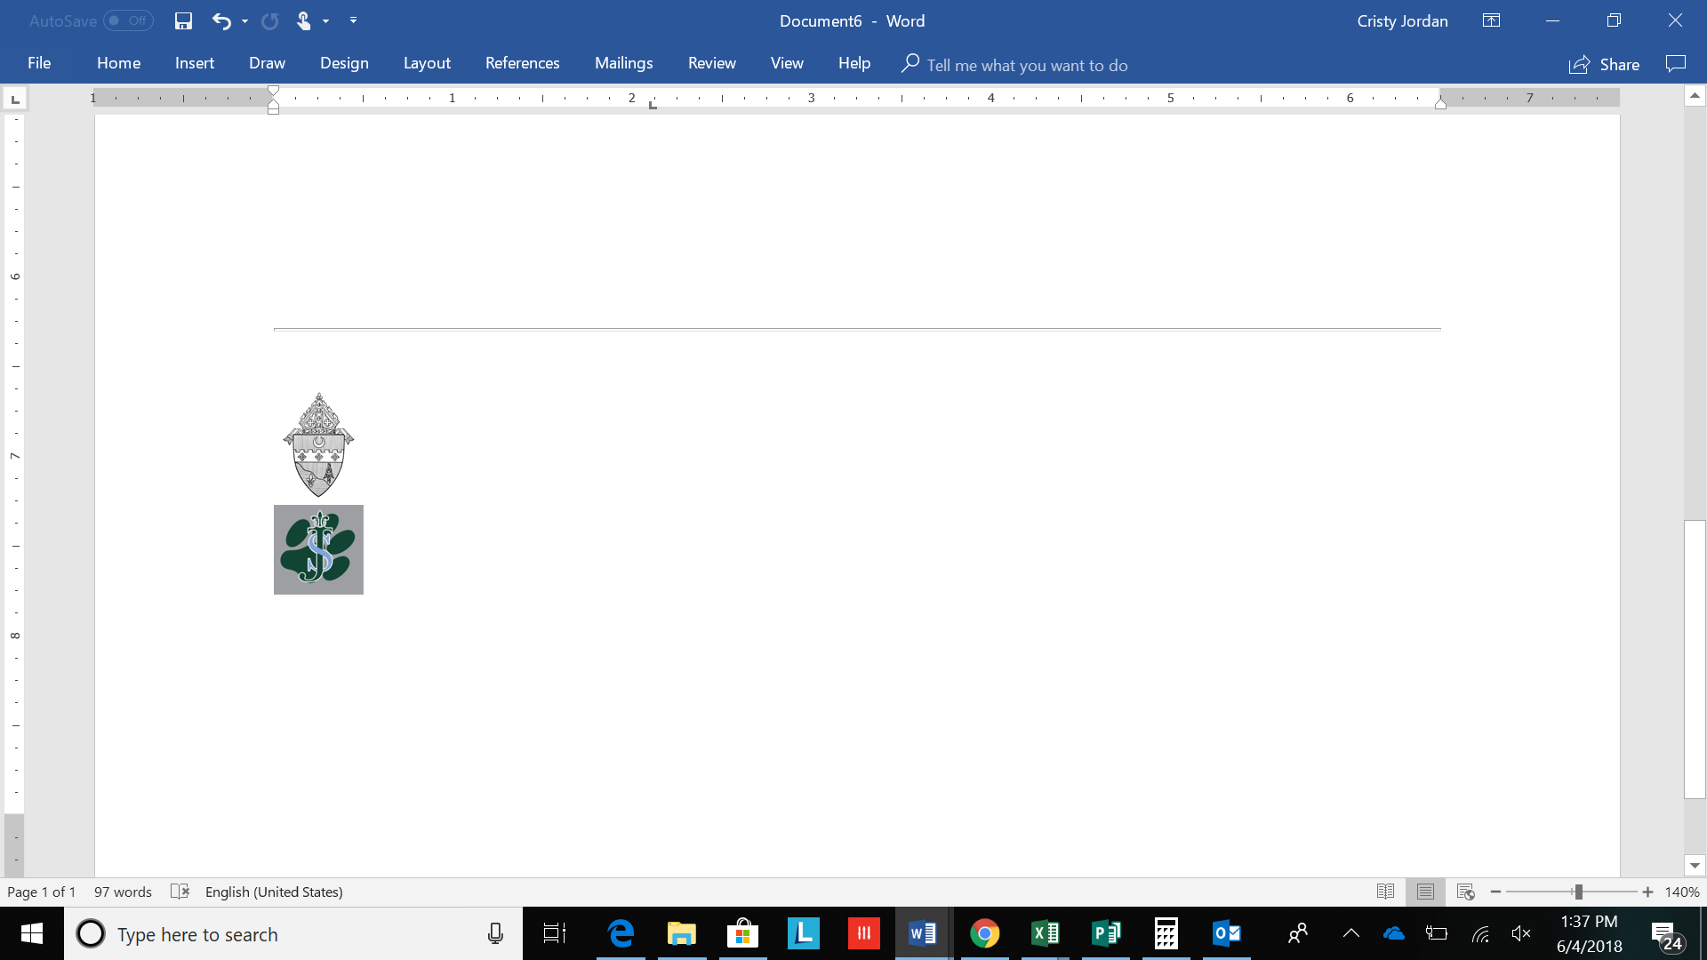Saint Joseph Catholic

**MISSION STATEMENT**

Our mission is to create a spiritual community of learning that educates and inspires students to reach their God-given potential.

​

***MOTTO***

*Learning to lead and serve as Saints*

ADDRESS

2211 Brooklyn Ave

Fort Wayne, IN |46802

CONTACTS

**Pastor: Fr. Evaristo Olivera**

260.432.5113 ext 339

Fr.Evaristo.Olivera@

SAINTJOSEPHCATHOLICFW.ORG

**Principal: Cristy Jordán**

260.432.4000 ext 333

cjordan@

SAINTJOSEPHCATHOLICFW.ORG

**Accounting: Patty Sermersheim**

260.432.5113 ext 326

psermersheim@

SAINTJOSEPHCATHOLICFW.ORG

About: Collection Envelopes

October 16, 2019

Enclosed are 30 Church collection envelops for each Panther in your home. We hope to teach students about giving to special collections or the church by allowing them to give with their own envelopes. Kids collections will only be done during our all school Masses. I have listed remaining all school Masses below. A child’s contribution is a gift and not mandatory but truly appreciated. I will talk in person to your child(ren) in class.

Thank you,

Cristy Jordán

October 25th

November 1st 6th 13th 20th

December 6th 11th 12th 20th

January 6th 10th 17th 24th 31st

February 7th 21st 26th 28th

March 6th 13th 19th

April 9th 17th 24th

May 1st 8th 15th 21st 22nd 27th